# Two kinds of Sliding window

* Fixed Size
* Dynamic size
  + Cater pillar visualize

# When we use Sliding window

* 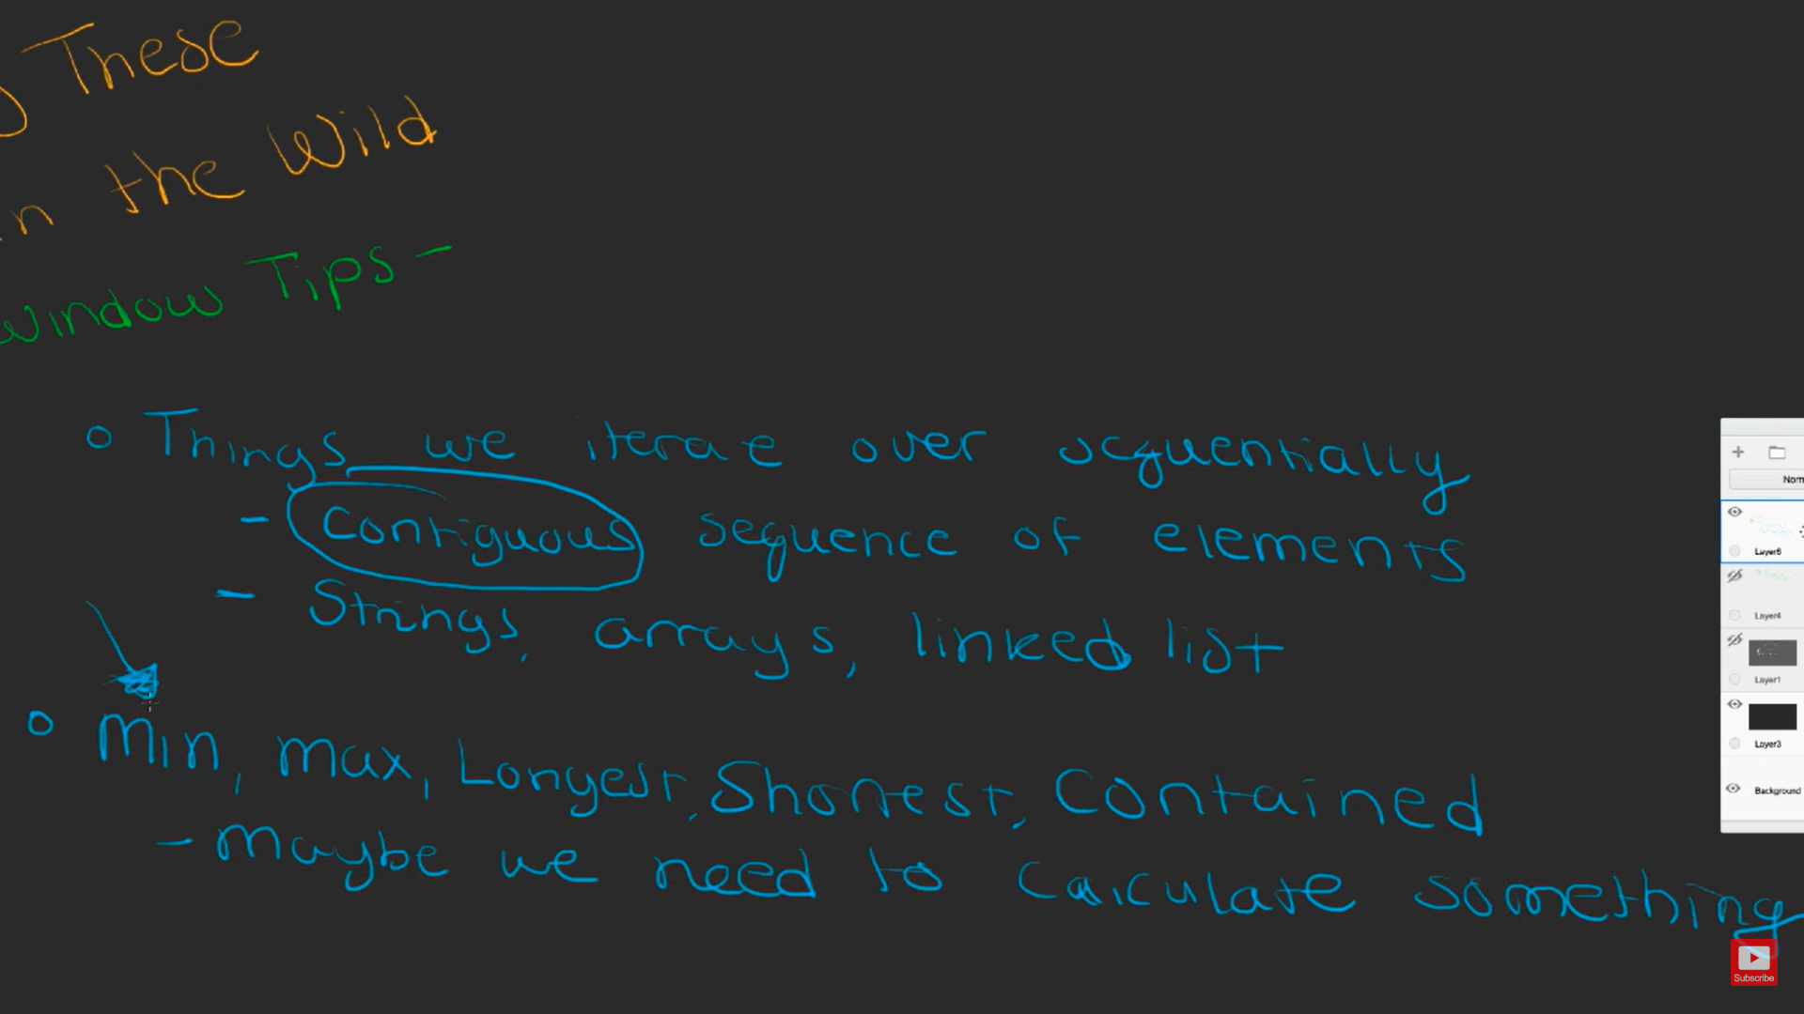

# Variant

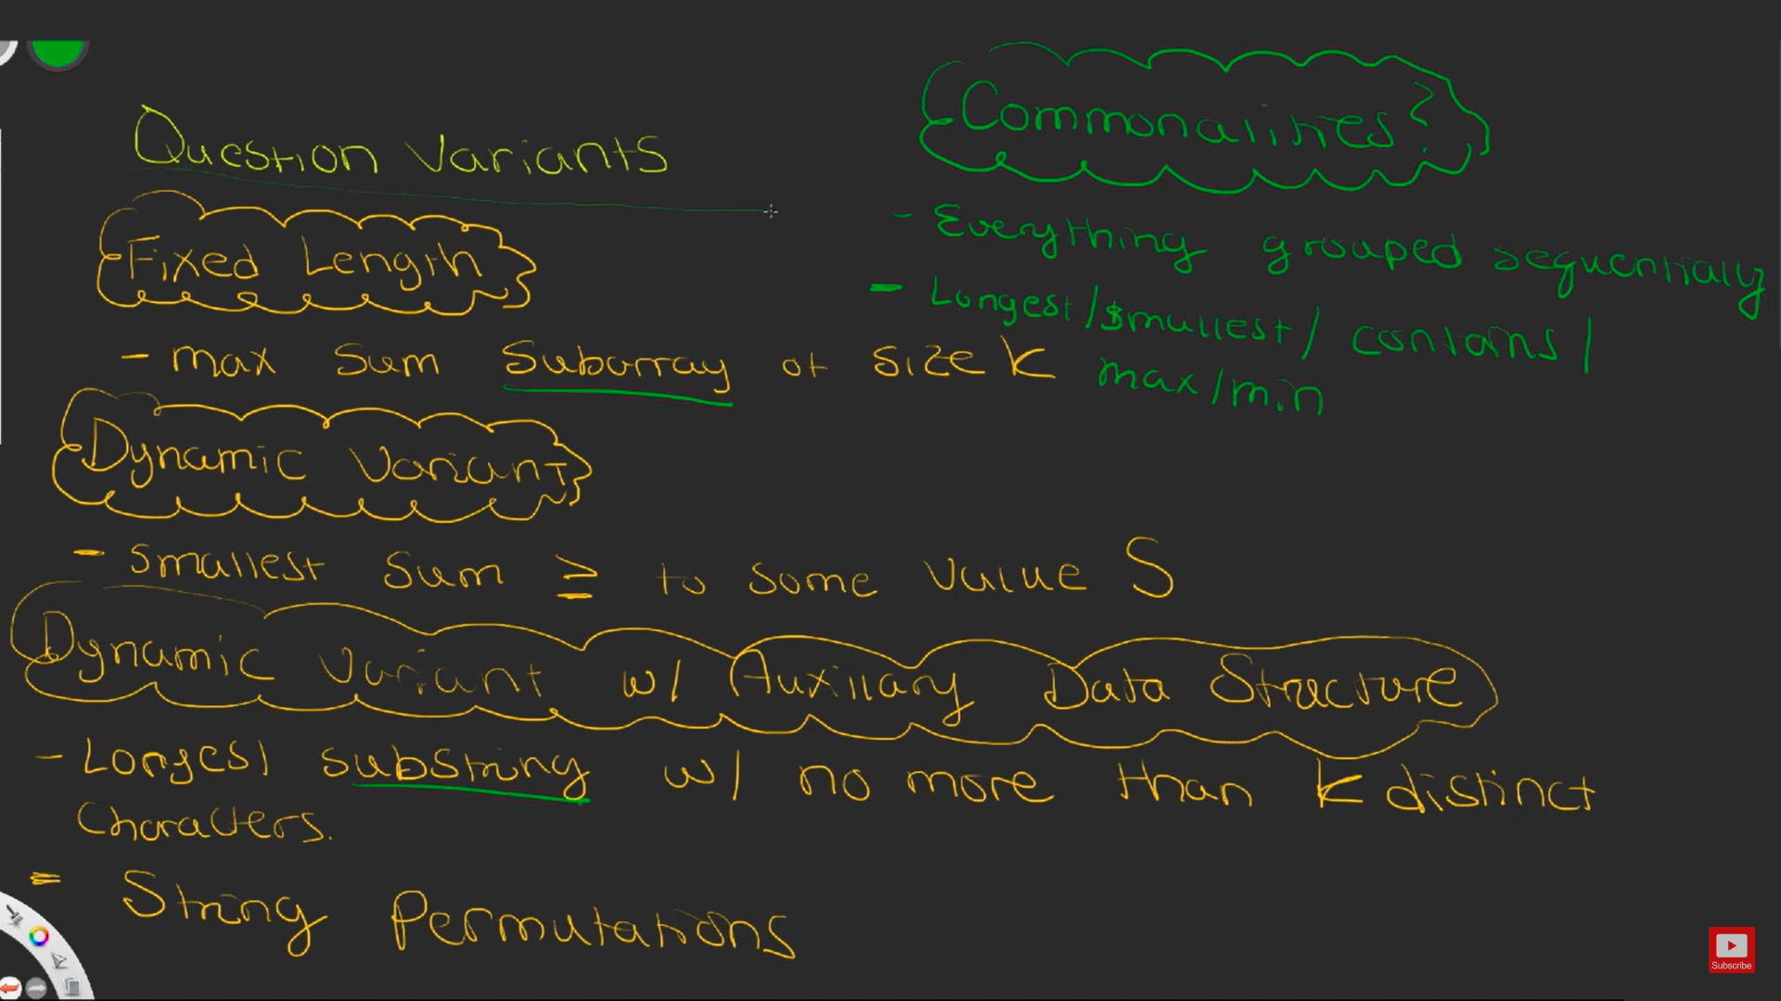

# Time Complexity

* + O(N)

# Tricks

## Way 1

* + Two for loop needed
  + First for loop – calculate sum of 4 index from 0 to 3 index
  + Second for loop - remove left index value from kth index

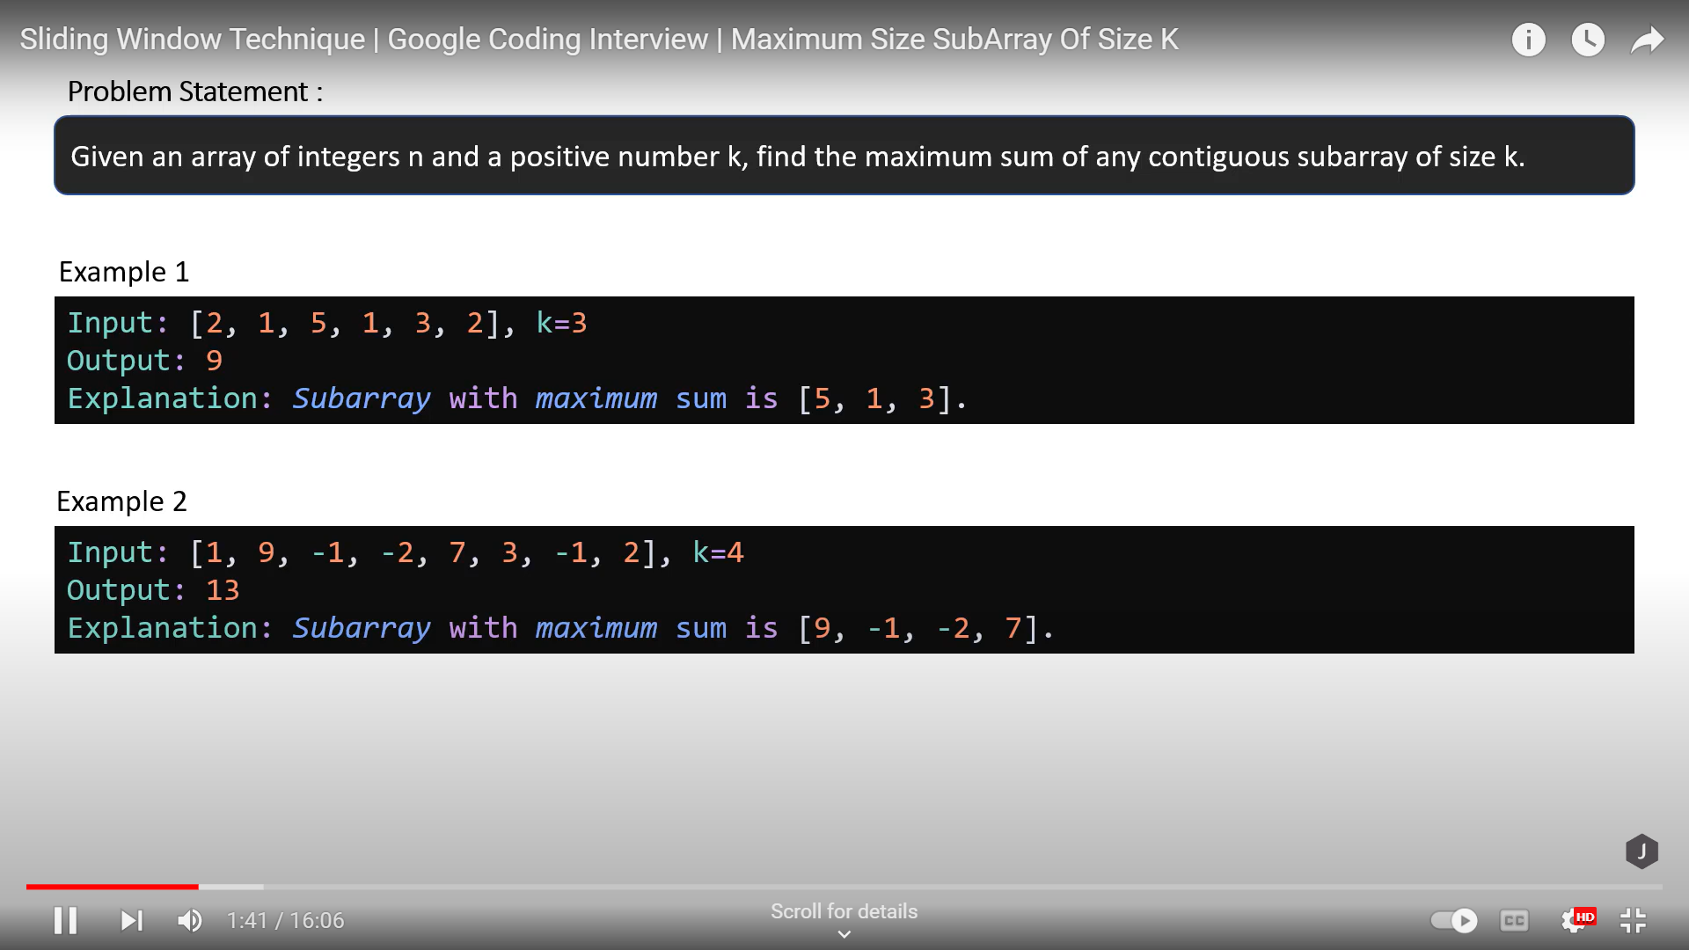

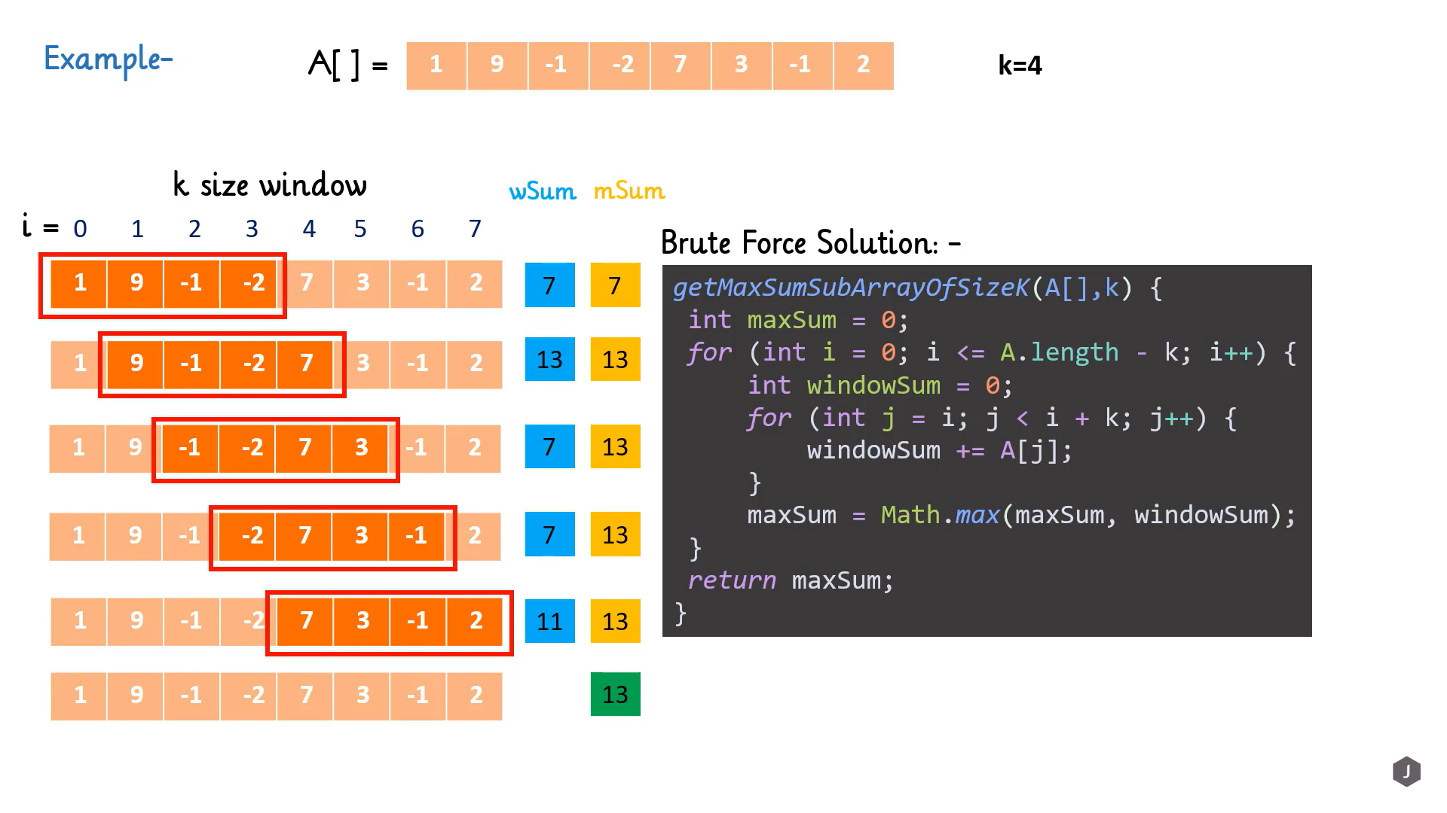

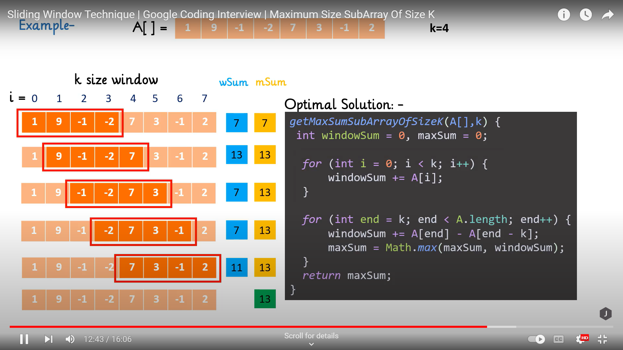

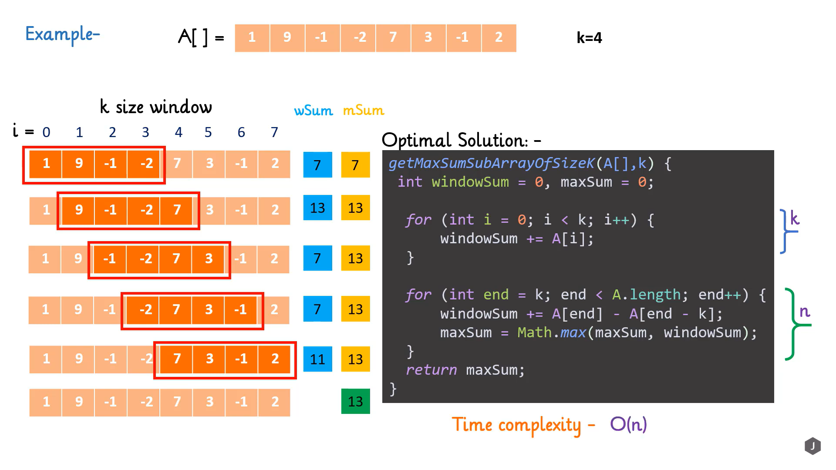

# Other way

* <https://www.youtube.com/watch?v=MK-NZ4hN7rs>

